Blood Bank DataBase Managing System

Database class project 2020/2021

|  |  |  |  |  |
| --- | --- | --- | --- | --- |
| Student Name in English | Student Name in Arabic | Student ID | Section | Work percentage |
| Ahmad Atout | احمد عطعوط | 11822841 | 9.5_11 | 50% |
| Ibrahim Shalhoub | ابراهيم شلهوب | 11941530 | 9.5_11 | 50% |
|  |  |  |  |  |

9\5\2021

---------------------------------------------This section is intended for the Instructor---------------------------------------

|  |  |
| --- | --- |
| **Topic** | **Mark** |
| Project Requirements and Modeling |  |
| Correctness of Database mapping |  |
| Functional Dependency and Normalization |  |
| Project Tools |  |
| Project Discussion |  |
| Project Completeness |  |
| Project Output Results or reporting (JasperReport, charts, graphs, etc.) |  |
| Project Administration and Management |  |
| Project Report |  |
| Project Idea |  |
| Project Complexity |  |
| Team work |  |
|  |  |
|  |  |
|  |  |

**Abstract:**

The main idea of this project is to simplify The process of blood donation, so that the blood donor gets encouraged to donate and make the society a better place And to make it easier for hospitals or any medical centers to find and request blood units in their area. The donor can log in to this application and enter his information and an email will be sent to him with details about his donation appointment and the requester can easily log in and make a request with the details about what kind of blood type needed and how many blood units needed, thus we will have a complete program to interact with the blood donors and the blood requesters and have an entire data base holding the information about every donor, requester and the details about every donation or request that was ever made in this center.

**Introduction:**

This blood bank Db managing system consists of both front-end and back-end that works together to build an entire system that any user could interact with, and creates a complete Enviromint that is easy to deal with. The back end consists of the data base tables and its attributes and some relation connecting the tables together that was created on the oracle data base using DDL to create the tables and sequences and the DML to populate these tables with data. The back end was built on the net beans using Java language to create an easy interface for the user and to connect it with the data base so the user doesn’t have to deal with the complexity of interacting and dealing with the data base.

Project requirements:

The data base keeps track of three types of users: employees, requester and donor. Each user has a unique username, password.

Every employee has a Fname, Mname, Lname, Email, unique ID, Job, Working hours, paid per hour, salary, cv.

The requester is a hospital who needs some amount of blood units and orders it from this blood centre. Every requester has an Email, unique hospital name, an address and a contact number.

We also keep track of the doner info such as the doner unique ID, his fname, Mname , Lname, City, Birth date, smoker or not, gender, contact number, address, blood group, Tattooed or not And when was the last time he made a donation.

The donor donates A donation that will be added to the donation table holding information about the donation ID, how many units donated, date of donation, blood group, and the donor ID.

We also keep track of the requests received to this blood centre that the requester orders so that every request has a unique ID and the blood group needed and how many units needed and the time and date that request was done and the requester(hospital) name.

UML diagram:

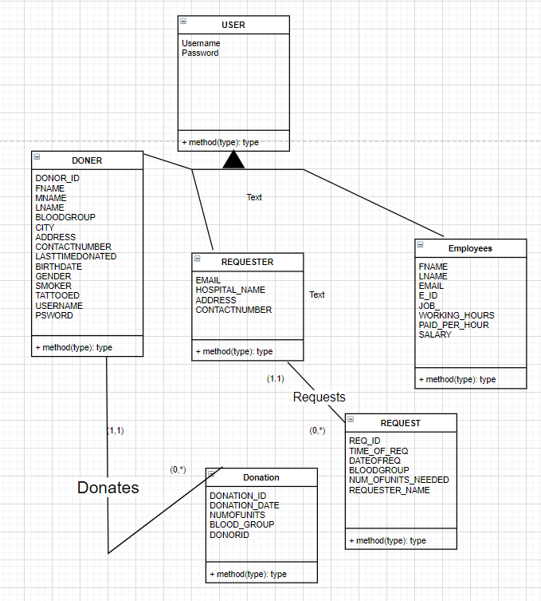

**Project tools:**

* Netbeans 12.2, java language, (please install the jcalander librires): to creater the GUI
* Oracle Sql developer
* JasperReport and all its important libraries.

**GUI:**

First of all we have the login page with two textfields one to enter the username and the other to enter your password and a log in button to log in using these details and a signup button to signup a new user and a close button to close the program

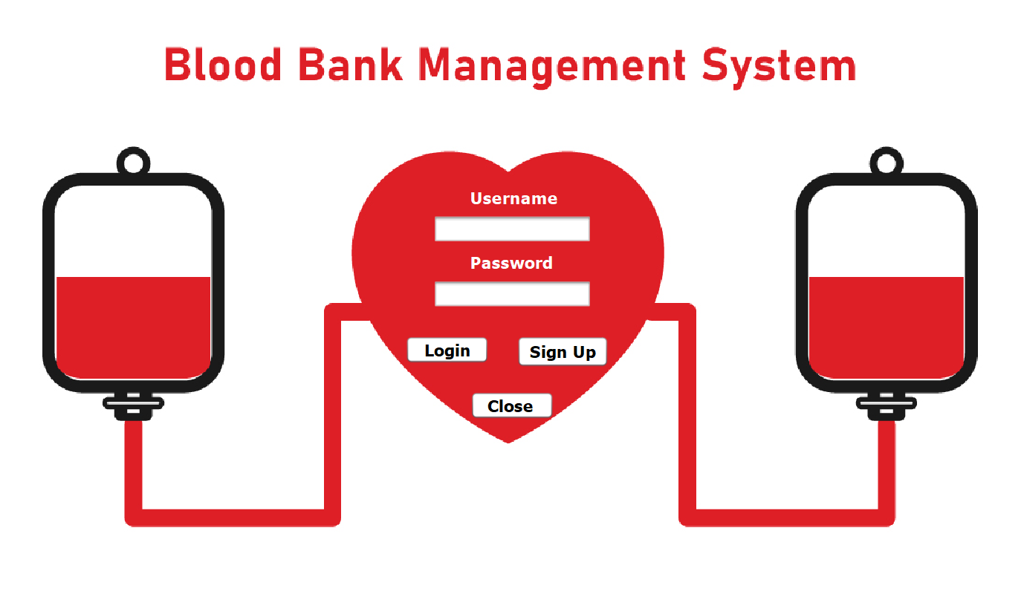

There is 4 types of users and each of them has a page alone, the picture bellow shows the admin page that u will need to enter username:Admin,password:Admin to enter it

And the Admin has an accessibility to do everything such as adding a new Donor, viewing all the donors details , delateing donors, viewing the stock details, increasing and decreasing the stock, adding a new employee, adding a new requester...etc

There is a bar that u can select any of its tabs a menu will show up viewing all the options u can do.

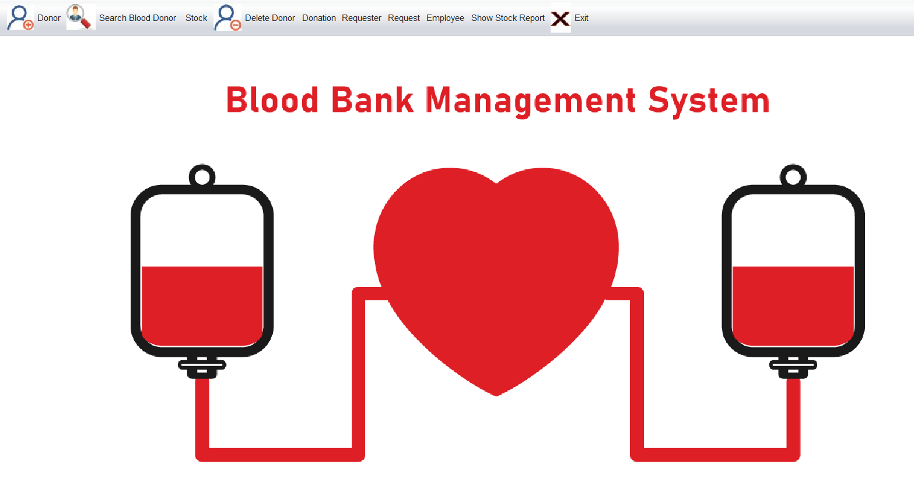

This page is to delete the donor by searching for him by his ID

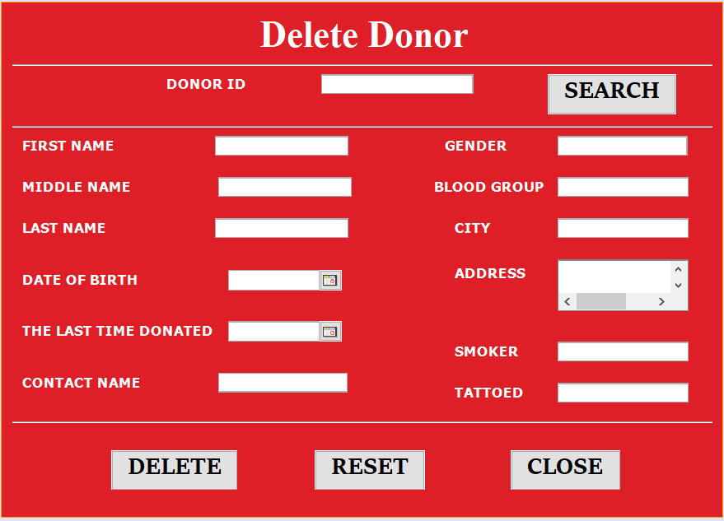

This page is to view all the donor details in a jtable

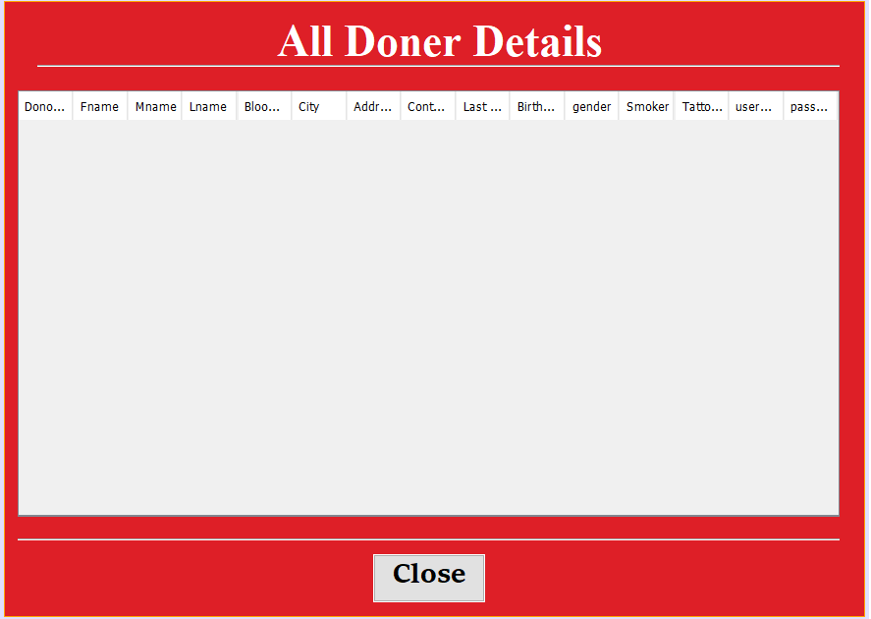

This page is to insert a new donation

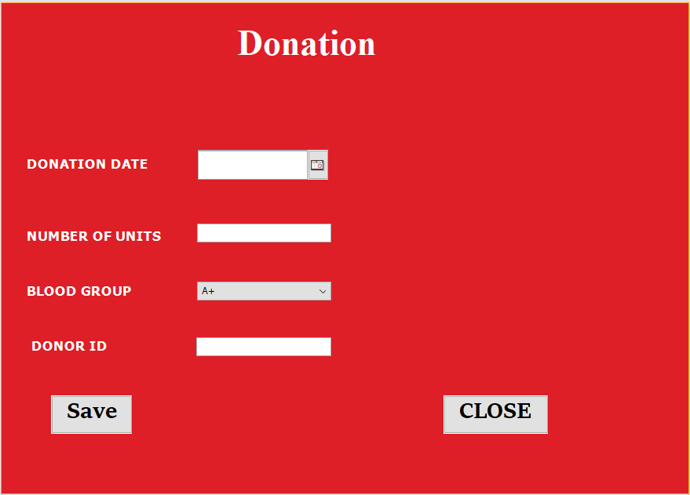

This page is to add a new employee

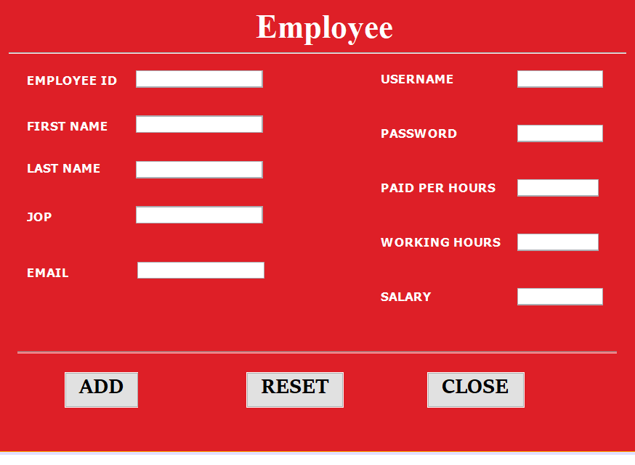

This page is to view all the employees details

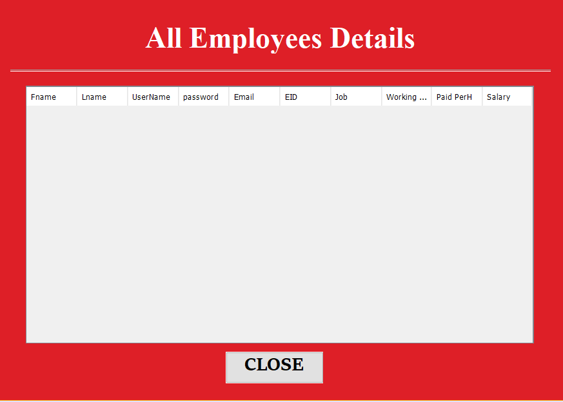

This page is to make a request

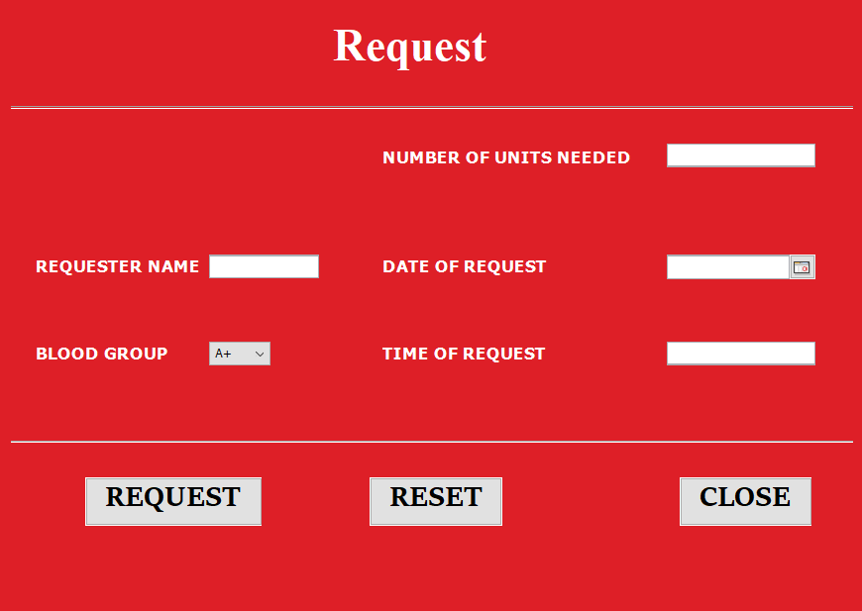

This page is to add a new requester

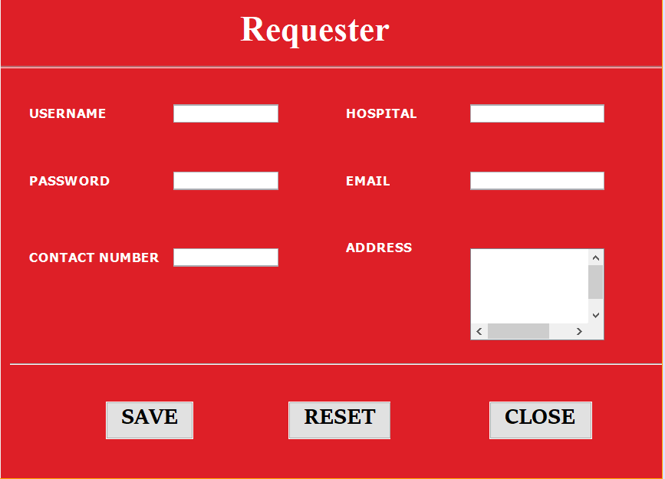

This page is to search for blood donors based on their bloodgroup

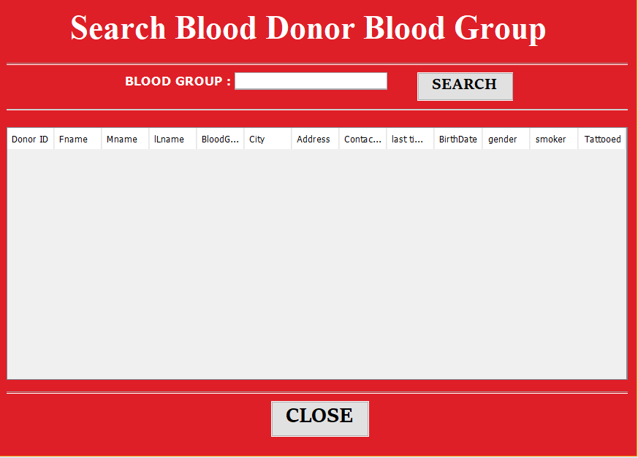

This page is to search for blood donors based on their location

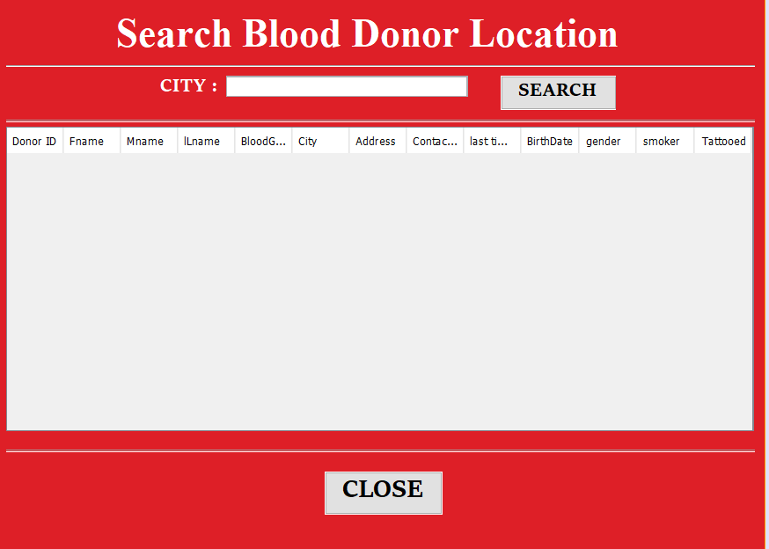

This page is to choose a bloodgroup and decrease the number of its units

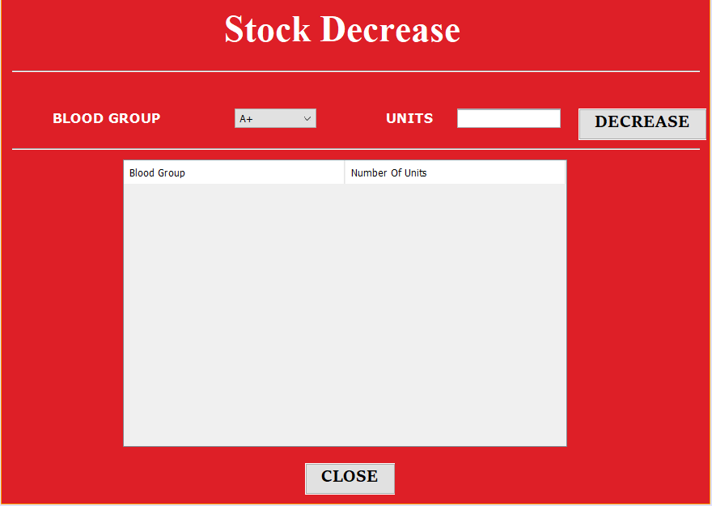

This page is to increase the num of units of a bloodtype

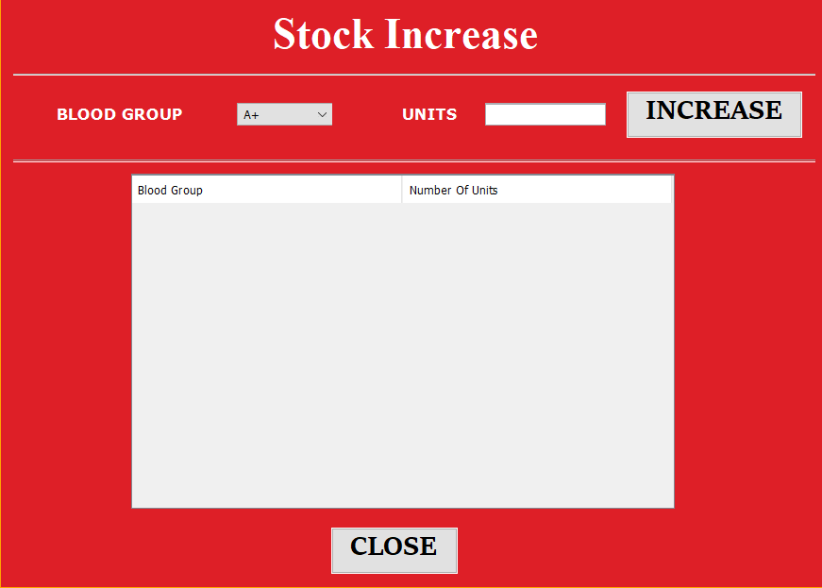

This page is to view all the stock details

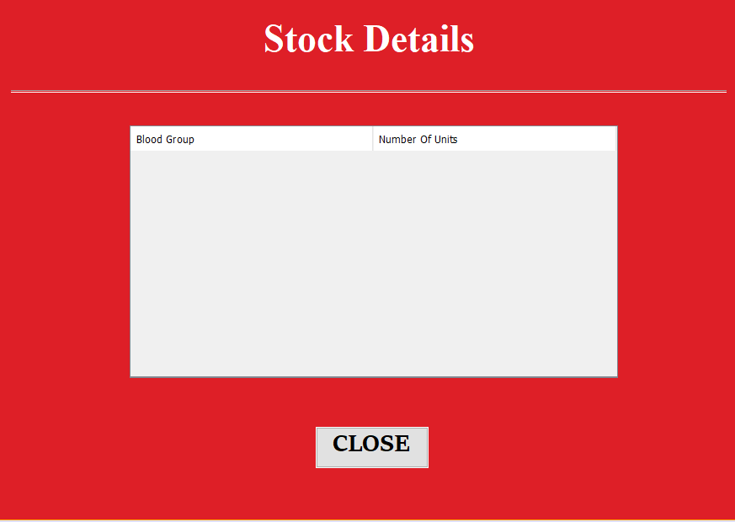

This page is to update donors details

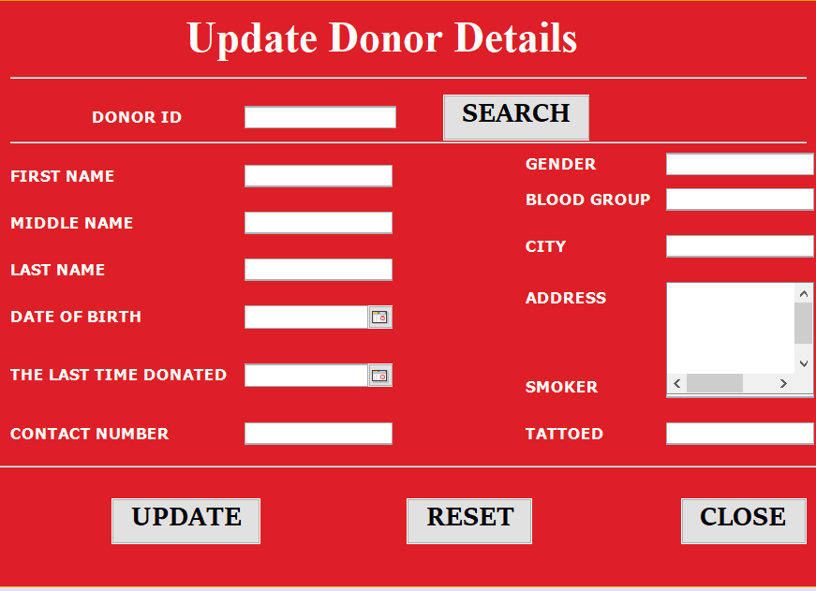

This page is to add a new donor to the system

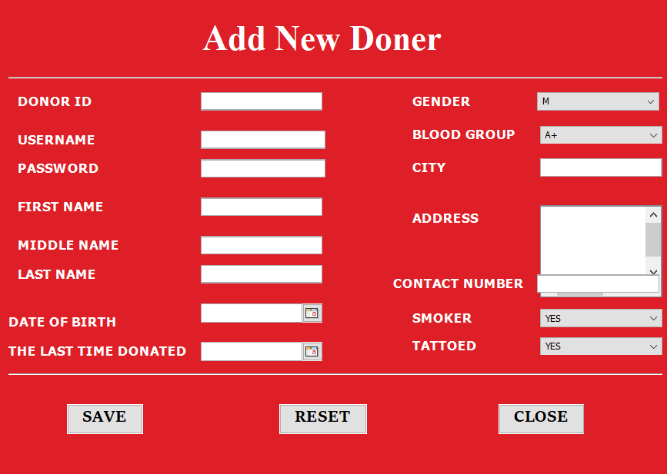

The second type of user is the donor who can sign up with a new username and password and then add his information to the system

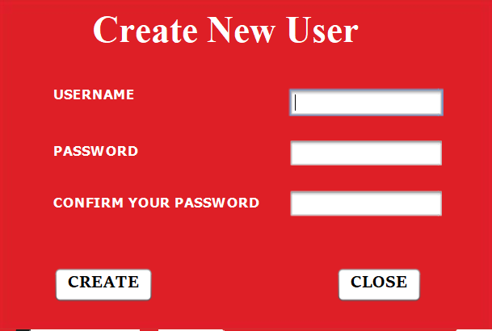



When the donor logs in this page will show up

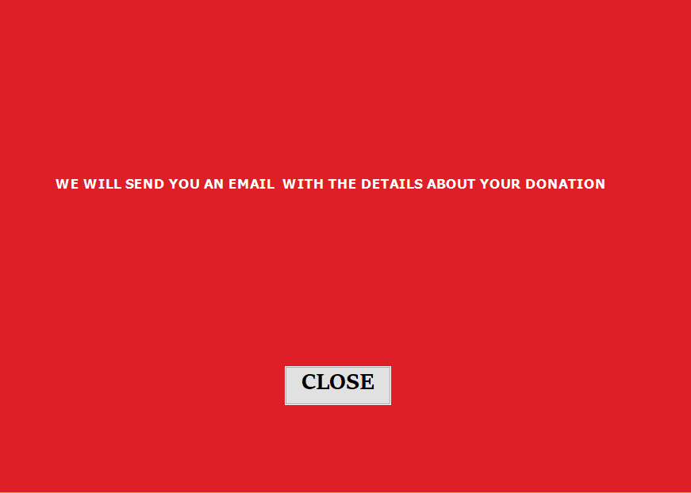

When the employee logs in this page will show up

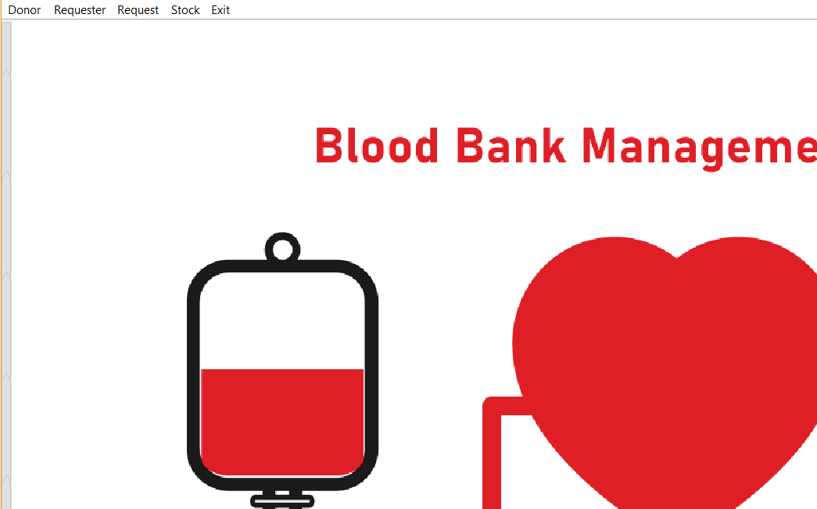

When the requester logs in this page will show up

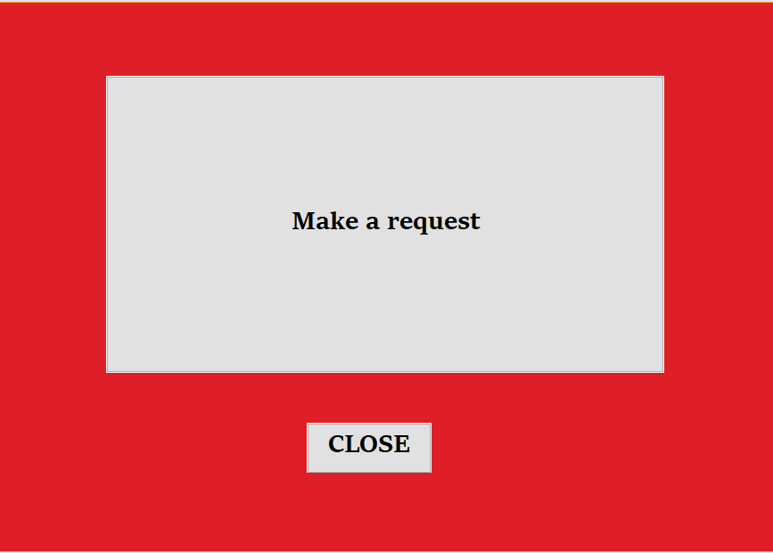

Conclusion:

The data base makes the process of dealing with huge amount of data so easy for humans and with it we can create lots of helpful applications like this one, this project will help to orgnize the blood bank data and make the blood donation process easy to help the society.

References:

Data base slides and lectures by dr sufyan samara